AGENCY MEMBERSHIP
2024 Application Form

Agency Name: Phone:

Street Address: Fax:

City: State: Zip:

Contact Name: Title:

Contact Email address:

Agency Website: Year Established:

Agency Membership dues are based on your 2023 home care aide payroll per the following schedule (Please check the Dues Tier that applies to your agency):
 | Tier | Home Care Aide Payroll | Agency Membership Dues
◻ | 1 | Less than $500,000 | $750
◻ | 2 | $500,000 - $999,999 | $1,500
◻ | 3 | $1,000,000 - $1,999,999 | $2,000
◻ | 4 | $2,000,000 - $2,999,999 | $2,500
◻ | 5 | $3,000,000 - $4,999,999 | $3,000
◻ | 6 | $5,000,000 - $6,999,999 | $5,000
◻ | 7 | $7,000,000 or $9,999,999 | $7,000
◻ | 8 | $10,000,000 or over | $10,000
Please indicate your corporate-wide 2023 Home Care Aide wages $
(Agencies choosing not to submit payroll data will be charged dues of $10,000)

Please note, if your membership is currently at Tier 6 or 7 and you merge with another agency, your dues will be bumped up to the next highest tier.

I confirm that the information completed above is complete and accurate.

Authorized Signature Date

Please note that 9.4% of your 2024Annual dues are not tax deductible because they are associated with lobbying activities.

PAYMENT INFORMATION

◻ Dues Enclosed: Amount Paid: $
◻ Please Bill Me:

◻ One Payment

◻ Two Payments (This Payment Option is Available for Tier 3-7 only)

Checks can be made payable to: Home Care Aide Council

To pay by credit card (VISA, MasterCard, American Express only), please complete the information below.

Card Number

Exp. Date / (Month/Year)

VISA/MasterCard 3-digit code on reverse American Express 4-digit code on front

Cardholder’s Name

Billing Address

City State Zip

Signature of Cardholder

Please return this form and payment to the Council office by mail at the address below or email to jwattfaqir@hcacouncil.org or by mail to:

Home Care Aide Council
PO Box 6828
Holliston, MA 01746
857-404-6766

QUESTIONNAIRE FOR LISTING IN THE COUNCIL’S 2024 MEMBER DIRECTORY

The listing of all Council Agency members is now available on our website www.hcacouncil.org. Please review the information below which is contained in your current Directory listing. If you need to make any changes to your listing, please correct below and return to the Council. Or, you may now also log into the “Member’s Only” portal of our website to make these corrections. If your agency has branch offices that are fully staffed, please duplicate the form and fill out for each branch office.

◻ The below information is correct.

Signature: Date:

Agency Name:
Address: City: State: MA Zip:
Telephone: Fax: Website:

Please check all that apply:
Certified Agency
EOEA Contract Agency
MRC Contract Agency
JCAHO Accredited
CHAP Accredited
Private Pay Services Available
Please check all that apply:
Is your agency affiliated with a certified agency?
Is your agency affiliated with a hospital?
Is your agency a franchise?

If your agency is part of an “umbrella” agency, please list your affiliate agencies in Massachusetts:

Type of services available through your agency (Please check all that apply):

24/7 |  | Evening |  | Hospice/ End-of-Life |  | Personal Care Homemaker
Case Management |  | Hands-on Non-Skilled |  | Live-Ins |  | Supportive Home Care Aide
Child/Maternity Care |  | Holiday |  | Medication Reminders |  | Transportation
Chore |  | Home Health Aide |  | Nursing |  | Weekend
Companion |  | Homemaker |  | Overnight |  | Other, please specify

Cities/Towns served:

City/Town 1: City/Town 16:
City/Town 2: City/Town 17:
City/Town 3: City/Town 18:
City/Town 4: City/Town 19:
City/Town 5: City/Town 20:
City/Town 6: City/Town 21:
City/Town 7: City/Town 22:
City/Town 8: City/Town 23:
City/Town 9: City/Town 24:
City/Town 10: City/Town 25:
City/Town 11: City/Town 26:
City/Town 12: City/Town 27:
City/Town 13: City/Town 28:
City/Town 14: City/Town 29:
City/Town 15: City/Town 30:

Additional Cities/Towns:

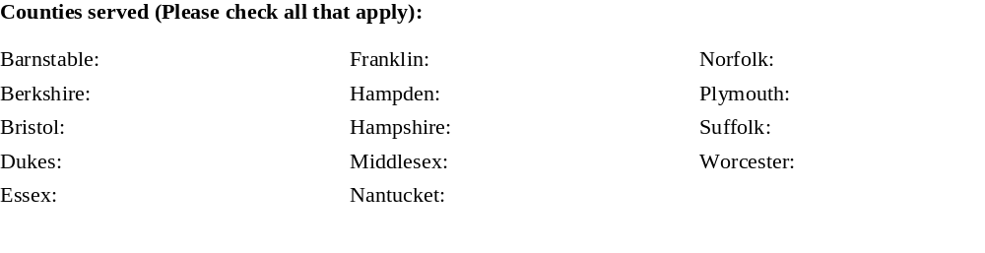PLEASE RETURN BY MAIL TO: Home Care Aide Council
PO Box 6828
Holliston, MA 01746
OR BY EMAIL TO jwattfaqir@hcacouncil.org

